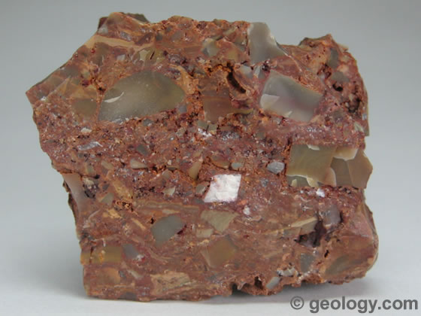

The formation of sedimentary rocks varies so there are a variety of sedimentary rocks. All of these rocks require a very long time for the processes of weathering, erosion, deposition, compaction and cementation to occur. These processes can take millions of years.
Three types of sedimentary rocks are formed when weathered rock particles, organisms die or precipitated particles are compacted and cemented together. These three types of rocks are referred to as clastic sedimentary rock, organic sedimentary rock and chemical sedimentary rock, respectively.
Clastic sedimentary rocks consist of smaller rocks cemented together. Examples include conglomerate and brecchia.
Organic sedimentary rock is formed when organisms die and layers form that are eventually covered by clastic sedimentary rock and compressed. Examples include coal and limestone.
Chemical sedimentary rocks form as a result of a chemical reaction that produces a precipitation. Banded iron formations (BIF) are chemical sedimentary rocks that contain iron oxide layers and are usually composed of the minerals magnetite and hematite.

Give the meaning of the following words in the paragraphs above:

1. Formation _____________________________________________________________

2. Weathering ____________________________________________________________

3. Erosion _______________________________________________________________

4. Deposition ____________________________________________________________

5. Compaction ___________________________________________________________

6. Cementation ___________________________________________________________

7. Organic _______________________________________________________________

8. Precipitated ___________________________________________________________
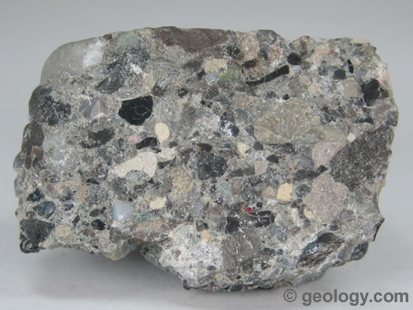

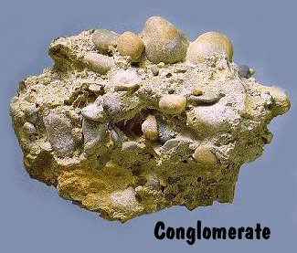
Which words or phrases in the text can be replaced with the following:

1. Differs _______________________________________________________________

2. Need _________________________________________________________________

3. Squashing together _____________________________________________________

4. Gluing together ________________________________________________________

5. Created _____________________________________________________________

6. Called _______________________________________________________________

7. In the end _____________________________________________________________

8. Have _________________________________________________________________
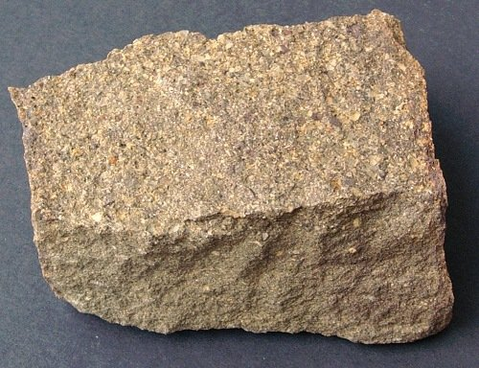

Questions

1. What processes need to happen for a sedimentary rock to form? _______________

__________________________________________________________________

2. How long can a sedimentary rock take to form? ____________________________

__________________________________________________________________

3. What are the three sedimentary rocks? ___________________________________

__________________________________________________________________

4. What are clastic rocks made of? ________________________________________

__________________________________________________________________

5. Name a clastic sedimentary rock _______________________________________

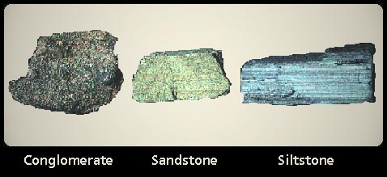

6. What are organic sedimentary rocks made of? _____________________________

__________________________________________________________________

7. Name an organic sedimentary rock ______________________________________

8. How do chemical sedimentary rocks form? _______________________________

__________________________________________________________________

9. Name a chemical sedimentary rock _____________________________________


